TypeScript Tutorial – QA Mitra

Introduction to TypeScript
TypeScript is a superset of JavaScript.
TypeScript builds on top of JavaScript. First, you write the TypeScript code. Then, you compile the TypeScript code into plain JavaScript code using a TypeScript compiler.
Once you have the plain JavaScript code, you can deploy it to any environment that JavaScript runs.
TypeScript files use the .ts extension rather than the .js extension of JavaScript files.
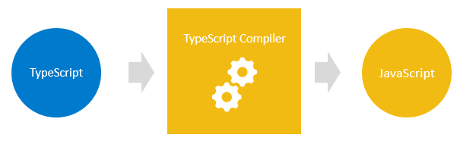
TypeScript uses the JavaScript syntaxes and adds additional syntaxes for supporting Types.
If you have a JavaScript program without any syntax errors, it is a TypeScript program. This means that all JavaScript programs are TypeScript programs. This is very helpful if you migrate an existing JavaScript codebase to TypeScript.
The following diagram shows the relationship between TypeScript and JavaScript:
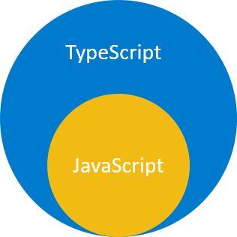
Why TypeScript
The main goals of TypeScript are:
- Introduce optional types to JavaScript.

JavaScript:
function add(x, y) {
return x + y;
}

TypeScript:
function add(x: number, y: number) : number {
return x + y;
}

TypeScript Setup

Summary: in this section, you’ll learn how to set up a TypeScript development environment.
The following tools you need to set up to start with TypeScript:
- Node.js – Node.js is the environment in which you will run the TypeScript compiler. Note that you don’t need to know Node.js.
- TypeScript compiler – a Node.js module that compiles TypeScript into JavaScript.
- Visual Studio Code or VS Code – a code editor supporting TypeScript. VS Code is highly recommended. However, you can use your favourite editor.
If you use VS Code, you can install the following extension to speed up the development process:
- Live Server – allows you to launch a development local web server with the hot reload feature.
Install Node.js
To install node.js, you follow these steps:
- Go to the Node.js download page.
- Download the suitable Node.js version for your platform such as Windows, macOS, or Linux.
- Execute the downloaded Node.js package or execution file. The installation is quite straightforward.
- Verify the installation by opening the Terminal on macOS and Linux or the Command Prompt on Windows and typing the command node -v, you should see the installed version of Node.js.
Install TypeScript compiler
To install the TypeScript compiler, you launch the Terminal on macOS or Linux and Command Prompt on Windows and type the following command:
npm install -g typescript
After the installation, you can type the following command to check the current version of the TypeScript compiler:
tsc --v
It should return the version like this:
Version 22.0.1
Note that your version is probably newer than this version.
If you’re on Windows and get the following error:
'tsc' is not recognized as an internal or external command, operable program or batch file.
… then you should add the following path C:\Users\<user>\AppData\Roaming\npm to the PATH variable. Notice that you should change the <user> to your Windows user.

Install tsx module
If you want to run TypeScript code directly on Node.js without precompiling, you can use the tsx module.
To install the tsx module globally, run the following command from the Terminal on macOS and Linux or Command Prompt on Windows:
npm install -g tsx
Install VS Code
To install the VS Code, you follow these steps:
- Navigate to the VS Code download page.
- Download the latest version of VS Code that suits your OS (Windows, macOS, or Linux)
- Execute the downloaded package or the installer file to launch the setup wizard. The installation process is also quite straightforward.
- Launch the VS Code.
You’ll see the VS Code as shown in the following picture:
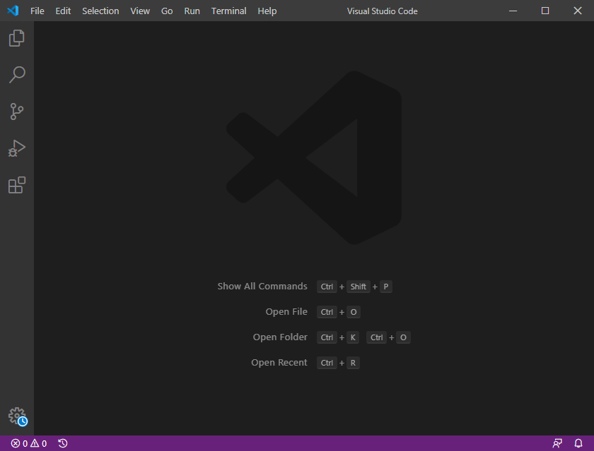
To install the Live Server extension, you follow these steps:
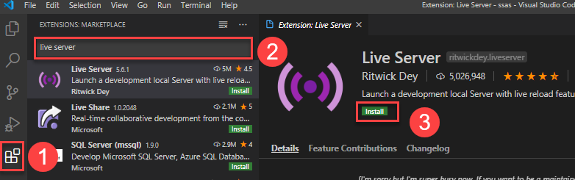
- Click the Extensions tab to find the extensions for VS Code.
- Type the live server to search for it.
- Click the install button to install the extension.
Summary
- A TypeScript compiler compiles the TypeScript into JavaScript.
- Use the tsc command to compile a TypeScript file to a JavaScript file.
- Use the tsx module to run TypeScript directly on Node.js without precompiling it to JavaScript.

TypeScript “Hello, World!”

Summary: in this section, you’ll learn how to develop the Hello World program in TypeScript.
TypeScript Hello World program in Node.js
- Create a new directory to store the code, e.g., helloworld.
- Launch VS Code and open the newly created directory.
- Create a new TypeScript file called app.ts. The extension of a TypeScript file is .ts.
- Type the following source code in the app.ts file:
let message: string = 'Hello, World!';
console.log(message);
- Launch a new Terminal within the VS Code by using the keyboard shortcut Ctrl+` or follow the menu Terminal > New Terminal
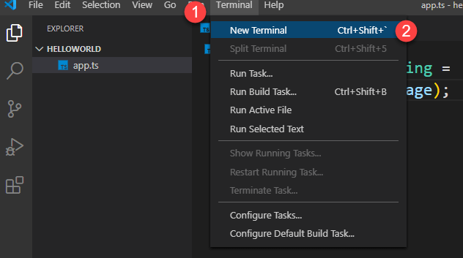

- Type the following command on the Terminal to compile the app.ts file:
tsc app.ts
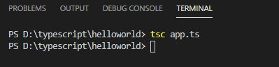
If everything is fine, you’ll see a new file called app.js is generated by the TypeScript compiler:
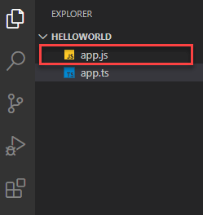
To run the app.js file in Node.js, you use the following command:
node app.js
If you installed the tsx module mentioned in the 2 . TypeScript Setup, you can use just one command to run the TypeScript file directly on Node.js without precompiling it to JavaScript:
tsx app.ts

Why TypeScript
Summary: in this section, you’ll learn why you should use TypeScript over JavaScript to avoid the problems created by the dynamic types.
Why use TypeScript
There are two main reasons to use TypeScript:
- TypeScript adds a type system to help you avoid many problems with dynamic types in JavaScript.
- TypeScript implements the future features of JavaScript.

This section focuses on the first reason.
Understanding dynamic type in JavaScript
JavaScript is dynamically typed. Unlike statically typed languages such as Java or C#, values have types instead of variables. For example:
"Hello"
From the value, you can tell that its type is string.
The following value is a number:
2024
See the following example:
let box;
box = "hello";
box = 100
The type of the box variable changes based on the value assigned to it.
To find the type of the box variable at runtime, you use the typeof operator:
let box;
console.log(typeof(box)); // undefined

box = "Hello";
console.log(typeof(box)); // string

box = 100;
console.log(typeof(box)); // number
In this example, the first statement defines a variable box without assigning a value. Its type is undefined.
Then, we assign the literal string "Hello" to box variable and show its type. The type of the box variable changes to string.
Finally, we assign 100 to the box variable. This time, the type of the box variable changes to number.
As you can see, as soon as the value is assigned, the type of the variable changes.
And you don’t need to explicitly tell JavaScript the type. JavaScript will automatically infer the type from the value.
Dynamic types offer flexibility. However, they also lead to problems.
Problems with dynamic types
Suppose you have a function that returns a product object based on an id:
function getProduct(id){
return {
id: id,
name: `Awesome Gadget ${id}`,
price: 99.5
}
}
The following uses the getProduct() function to retrieve the product with id 1 and show its data:
const product = getProduct(1);
console.log(`The product ${product.Name} costs $${product.price}`);
Output:
The product undefined costs $99.5
It isn’t what we expected.
The issue with this code is that the product object doesn’t have the Name property. It has the name property with the first letter n in lowercase.
However, you can only know it until you run the script.
Referencing a property that doesn’t exist on the object is a common issue when working in JavaScript.
The following example defines a new function that outputs the product information to the console:
const showProduct = (name, price) => {
console.log(`The product ${name} costs $${price}.`);
};
The following uses the getProduct() and showProduct() functions:
const product = getProduct(1);
showProduct(product.price, product.name);
Output:
The product 99.5 costs $Awesome Gadget 1
This time we pass the arguments in the wrong order to the showProduct() function. This is another common problem that you often have when working with JavaScript.
This is why TypeScript comes into play.
How Typescript solves problems of dynamic types
To fix the problem of referencing a property that doesn’t exist on an object, you do the following steps:
First, define the “shape” of the product object using an interface.
interface Product{
id: number,
name: string,
price: number
};
Second, explicitly use the Product type as the return type of the getProduct() function:
function getProduct(id) : Product{
return {
id: id,
name: `Awesome Gadget ${id}`,
price: 99.5
}
}
When you reference a property that doesn’t exist, the code editor will inform you immediately:
const product = getProduct(1);
console.log(`The product ${product.Name} costs $${product.price}`);
The code editor highlighted the following error on the Name property:
And when you hover the mouse cursor over the error, you’ll see a hint that helps you to solve the issue:
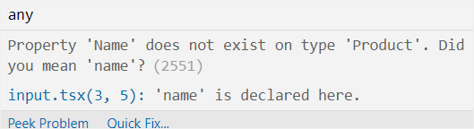
To solve the problem of passing the arguments in the wrong order, you explicitly assign types to function parameters:
const showProduct = (name: string, price:number) => {
console.log(`The product ${name} costs $${price}.`);
};
And when you pass the arguments of the wrong types to the showProduct() function, you’ll receive an error:
const product = getProduct(1);
showProduct(product.price, product.name);Code language: JavaScript (javascript)
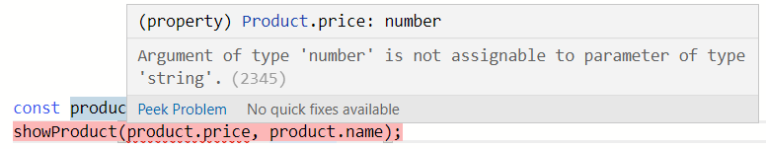

TypeScript Data Types
Summary: in this section, you’ll learn about the TypeScript datatypes and their purposes.
What is a type in TypeScript
In TypeScript, a type is a convenient way to refer to different properties and functions that a value has.
A value is anything you can assign to a variable e.g., a number, a string, an array, an object, and a function.
For example, see the following value:
'Hello'
When you look at this value, you can say it is a string. This value has properties and methods that a string has.
For example, the 'Hello' value has a property called length that returns the number of characters:
console.log('Hello'.length);
It also has many methods like match(), indexOf(), and toUpperCase(). For example:
console.log('Hello'.toUpperCase()); // HELLO
When you look at the value 'Hello' and describe it by listing the properties and methods, it would be inconvenient.
A shorter way to refer to a value is to assign it a type. In this example, you say 'Hello' is a string. Then, you know that you can use the properties and methods of a string for the value 'Hello'.
In conclusion, in TypeScript:
- a type is a label that describes the different properties and methods that a value has
- every value has a type.
DataTypes in TypeScript
TypeScript inherits the built-in types from JavaScript. TypeScript types are categorized into:
- Primitive types.
- Object types.
Primitive types
The following illustrates the primitive types in TypeScript:
Name | Description
string | Represent text data.
number | Represent numeric values.
boolean | Have true and false values.
Null | Have one value: null.
Undefined | Have one value: undefined. It is the default value of an uninitialized variable.
Any | Can allow any value

Object types
Object types are functions, arrays, classes, etc.
Purposes of types in TypeScript
There are two main purposes of types in TypeScript:
- First, types are used by the TypeScript compiler to analyze your code for errors.
- Second, types allow you to understand what values are associated with variables.

TypeScript Type Inference
Summary: in this section, you will learn about type inference in TypeScript.
Type inference describes where and how TypeScript infers types when you don’t explicitly annotate them.
Basic type inference
When you declare a variable, you can use a type annotations to explicitly specify a type for it. For example:
let counter: number;
However, if you initialize the counter variable with a number, TypeScript will infer the type of the counter to be number. For example:
let counter = 0;
It is equivalent to the following statement:
let counter: number = 0;
Likewise, when you assign a function parameter a value, TypeScript infers the type of the parameter to the type of the default value. For example:
function setCounter(max=100) {
// ...
}
In this example, TypeScript infers the type of the max parameter to be number.
Similarly, TypeScript infers the following return type of the increment() function as number:
function increment(counter: number) {
return counter++;
}
It is the same as:
function increment(counter: number) : number {
return counter++;
}
The best common type algorithm
Consider the following assignment:
let items = [1, 2, 3, null];
To infer the type of items variable, TypeScript needs to consider the type of each element in the array.
It uses the best common type algorithm to analyze each candidate type and select the type that is compatible with all other candidates.
In this case, TypeScript selects the number or null array type (number | null) []) as the best common type. Note that the | means the OR operator in types.
If you add a string to the items array, TypeScript will infer the type for the items as an array of numbers and strings: (number | string)[]
let items = [1, 2, 3, 'Cheese'];
Type inference vs. Type annotations
The following shows the difference between type inference and type annotations:
Type inference | Type annotations
TypeScript guesses the type | You explicitly tell TypeScript the type
So, when do you use type inference and type annotations?
In practice, you should always use the type inference as much as possible. You use the type annotation in the following cases:
- When you declare a variable and assign it a value later.
- When you want a variable that can’t be inferred.
- When a function returns the any type, you need to clarify the value.
Summary
- Type inference occurs when you initialize variables, set parameter default values, and determine function return types.
- TypeScript uses the best common type algorithm to select the best candidate types that are compatible with all variables.
- TypeScript also uses contextual typing to infer types of variables based on the locations of the variables.

TypeScript Number Datatype
Summary: in this section, you’ll learn about the TypeScript number data types.
All numbers in TypeScript are either floating-point values or big integers. The floating-point numbers have the type number while the big integers get the type bigint.

The number type
The following shows how to declare a variable that holds a floating-point value:
let price: number;
Alternatively, you can initialize the price variable to a number:
let price = 9.95;
Decimal numbers
The following shows some decimal numbers:
let counter: number = 0;
let x: number = 100,
y: number = 200;
Big Integers
The big integers represent the whole numbers larger than 2⁵³ – 1. A Big integer literal has the n character at the end of an integer literal like this:
let big: bigint = 9007199254740991n;
Summary
- All numbers in TypeScript are either floating-point values that get the number type or big integers that get the bigint type.

TypeScript String Datatype

Summary: in this section, you’ll learn about the TypeScript string data type.
Like JavaScript, TypeScript uses double quotes (") or single quotes (') to surround string literals:
let firstName: string = 'John';
let title: string = "Web Developer";
TypeScript also supports template strings that use the backtick (`) to surround characters.
The template strings allow you to create multi-line strings and provide string interpolation features.
The following example shows how to create a multi-line string using the backtick (`):
let description = `This TypeScript string can
span multiple
lines
`;
String interpolations allow you to embed the variables into the string like this:
let firstName: string = `John`;
let title: string = `Web Developer`;
let profile: string = `I'm ${firstName}.
I'm a ${title}`;

console.log(profile);
Output:
I'm John.
I'm a Web Developer.
Summary
- In TypeScript, all strings get the string type.
- Like JavaScript, TypeScript uses double quotes ("), single quotes ('), and backtick (`) to surround string literals.

TypeScript Boolean Datatype
Summary: in this section, you will learn about the TypeScript boolean data type and how to use the boolean keyword.
Introduction to the TypeScript boolean
The TypeScript boolean type has two values: true and false. The boolean type is one of the primitive types in TypeScript.
Declaring boolean variables
In TypeScript, you can declare a boolean variable using the boolean keyword. For example:
let pending: boolean;
pending = true;
// after a while
// ..
pending = false;
Boolean operator
To manipulate boolean values, you use the boolean operators. TypeScript supports common boolean operators:
Operator | Meaning
&& | Logical AND operator
|| | Logical OR operator
! | Logical NOT operator
For example:
// NOT operator
const pending: boolean = true;
const notPending = !pending; // false
console.log(result); // false

const hasError: boolean = false;
const completed: boolean = true;

// AND operator
let result = completed && hasError;
console.log(result); // false

// OR operator
result = completed || hasError;
console.log(result); // true
Summary
- TypeScript boolean type has two values true and false.
- Use the boolean keyword to declare boolean variables.

TypeScript object Type

Summary: in this section, you’ll learn about the TypeScript object type and how to write more accurate object type declarations.
Introduction to TypeScript object type
The TypeScript object type represents all values that are not in primitive types.
The following shows how to declare a variable that holds an object:
let employee: object;

employee = {
firstName: 'John',
lastName: 'Doe',
age: 25,
jobTitle: 'Web Developer'
};

console.log(employee);
Output:
{
firstName: 'John',
lastName: 'Doe',
age: 25,
jobTitle: 'Web Developer'
}
If you reassign a primitive value to the employee object, you’ll get an error :
employee = "Jane";
Error:
error TS2322: Type '"Jane"' is not assignable to type 'object'.
The employee object is an object type with a fixed list of properties. If you attempt to access a property that doesn’t exist on the employee object, you’ll get an error:
console.log(employee.hireDate);
Error:
error TS2339: Property 'hireDate' does not exist on type 'object'.

Note that the above statement works perfectly fine in JavaScript and returns undefined instead.
To explicitly specify properties of the employee object, you first use the following syntax to declare the employee object:
let employee: {
firstName: string;
lastName: string;
age: number;
jobTitle: string;
};
And then assign the employee object to a literal object with the described properties:
employee = {
firstName: 'John',
lastName: 'Doe',
age: 25,
jobTitle: 'Web Developer'
};
Or you can combine both syntaxes in the same statement like this:
let employee: {
firstName: string;
lastName: string;
age: number;
jobTitle: string;
} = {
firstName: 'John',
lastName: 'Doe',
age: 25,
jobTitle: 'Web Developer'
};
The empty type {}
TypeScript has another type called empty type denoted by {} , which is quite similar to the object type.
The empty type {} describes an object that has no property on its own. If you try to access a property on such an object, TypeScript will issue a compile-time error:
let vacant: {};
vacant.firstName = 'John';
Error:
error TS2339: Property 'firstName' does not exist on type '{}'.

Summary
- The TypeScript object type represents any value that is not a primitive value.
- The Object type, however, describes functionality that is available on all objects.
- The empty type {} refers to an object that has no property on its own.

TypeScript Array Type

Summary: in this section, you’ll learn about the TypeScript array type and its basic operations.
Introduction to TypeScript array type
A TypeScript array is an ordered list of data. To declare an array that holds values of a specific type, you use the following syntax:
let arrayName: type[];
For example, the following declares an array of strings:
let skills: string[] = [];
And you can add one or more strings to the array:
skills[0] = "Problem Solving";
skills[1] = "Programming";
or use the push() method:
skills.push('Software Design');
The following declares a variable and assigns an array of strings to it:
let skills = ['Problem Sovling','Software Design','Programming'];
In this example, TypeScript infers the skills array as an array of strings. It is equivalent to the following:
let skills: string[];
skills = ['Problem Sovling','Software Design','Programming'];
After you define an array of a specific type, TypeScript will prevent you from adding incompatible values. For example, the following will cause an error:
skills.push(100);
… because we’re trying to add a number to the string array.
Error:
Argument of type 'number' is not assignable to parameter of type 'string'.
When you extract an element from the array, TypeScript infers the type of array element. For example:
let skill = skills[0];
console.log(typeof(skill));
Output:
string
In this example, we extract the first element of the skills array and assign it to the skill variable.
Since an element in a string array is a string, TypeScript infers the type of the skill variable to string as shown in the output.
TypeScript array properties and methods
TypeScript arrays have the same properties and methods as JavaScript. For example, the following uses the length property to get the number of elements in an array:
let series = [1, 2, 3];
console.log(series.length);
You can use all the useful array methods such as foreach(), map(), reduce(), filter() For example:
let series = [1, 2, 3];
let doubleIt = series.map(e => e* 2);
console.log(doubleIt);
Output:
[ 2, 4, 6 ]
Storing values of mixed types
The following illustrates how to define an array that holds both strings and numbers:
let scores = ['Programming', 5, 'Software Design', 4];

In this case, TypeScript infers the scores array as an array of string | number. It’s equivalent to the following:
let scores : (string | number)[];
scores = ['Programming', 5, 'Software Design', 4

Summary
- In TypeScript, an array is an ordered list of values.
- Use the let arr: type[] syntax to declare an array of a specific type. Adding a value of a different type to the array will result in an error.
- An array can store values of mixed types. Use the arr: (type1 | type2) [] syntax to declare an array of values with mixed types (type1, and type2)

TypeScript Tuple
Summary: in this section, you’ll learn about the TypeScript Tuple type and its usage.
Introduction to TypeScript Tuple type
A tuple works like an array with some additional considerations:
- The number of elements in the tuple is fixed.
- The types of elements are known, and need not be the same.
For example, you can use a tuple to represent a value as a pair of a string and a number:
let skill: [string, number];
skill = ['Programming', 5];
The order of values in a tuple is important. If you change the order of values of the skill tuple to [5, "Programming"], you’ll get an error:
let skill: [string, number];
skill = [5, 'Programming'];
Error:
error TS2322: Type 'string' is not assignable to type 'number'.

For this reason, it’s a good practice to use tuples with data that are related to each other in a specific order.
For example, you can use a tuple to define an RGB color that always comes in a three-number pattern:
(r,g,b)
For example:
let color: [number, number, number] = [255, 0, 0];
The color[0], color[1], and color[2] would be logically mapped to Red, Green and Blue color values.
Optional Tuple Elements
Since TypeScript 3.0, a tuple can have optional elements specified using the question mark (?) postfix.
For example, you can define an RGBA tuple with the optional alpha channel value:
let bgColor, headerColor: [number, number, number, number?];
bgColor = [0, 255, 255, 0.5];
headerColor = [0, 255, 255];
Note that the RGBA defines colors using the red, green, blue, and alpha models. The alpha specifies the opacity of the color.
Summary
- A tuple is an array with a fixed number of elements whose types are known.

TypeScript any Type

Summary: in this section, you will learn about the TypeScript any type and how to use it properly in your code.
Introduction to TypeScript any type
Sometimes, you may need to store a value in a variable. But you don’t know its type when writing the program. And the unknown value may come from a third-party API or user input.
In this case, you want to opt out of the type checking and allow the value to pass through the compile-time check.
For example:
let result: any;

result = 1;
console.log(result);

result = 'Hello';
console.log(result);

result = [1, 2, 3];
const total = result.reduce((a: number, b: number) => a + b, 0);
console.log(total);
Output: 6
In this example:
- First, declare the variable result with the type any.
- Second, assign number 1 to the result and display its value to the console.
- Third, assign the string literal 'Hello' to the result and show its value to the console.
- Finally, assign an array of numbers to the result variable, calculate the total using the reduce() method, and log the total to the console.
Let’s take another typical example:
// json may come from a third-party API
const json = `{"latitude": 10.11, "longitude":12.12}`;

// parse JSON to find location
const currentLocation = JSON.parse(json);
console.log(currentLocation);
Code language: JavaScript (javascript)
Output:
{ latitude: 10.11, longitude: 12.12 }
In this example, TypeScript infers the value of the currentLocation variable as any. We assign an object returned by the JSON.parse() function the currentLocation variable.
However, when we access the non-existing property (x) of the currentLocation variable, TypeScript does not carry any checks.
This is working fine and shows an undefined value in the console:
console.log(currentLocation.x);
Output:
undefined
The TypeScript compiler doesn’t complain or issue any errors.
The any type provides you with a way to work with the existing JavaScript codebase. It allows you to gradually opt in and opt out of type-checking during compilation. Therefore, you can use the any type for migrating a JavaScript project over to TypeScript.
TypeScript any: implicit typing
If you declare a variable without specifying a type, TypeScript assumes that you use the any type. This feature is called type Inference. TypeScript guesses the type of the variable. For example:
let result;
In this example, TypeScript infers the type for you. This practice is called implicit typing.
Summary
- The TypeScript any type allows you to store a value of any type. It instructs the compiler to skip type-checking.
- Use the any type to store a value that you don’t know its type at the compile-time or when you migrate a JavaScript project over to a TypeScript project.

TypeScript union Type
Summary: in this section, you will learn about the TypeScript union type that allows you to store a value of one or several types in a variable.
Introduction to TypeScript union type
Sometimes, you will run into a function that expects a parameter that is either a number or a string. For example:
function add(a: any, b: any) {
if (typeof a === 'number' && typeof b === 'number') {
return a + b;
}
if (typeof a === 'string' && typeof b === 'string') {
return a.concat(b);
}
throw new Error('Parameters must be numbers or strings');
}
In this example, the add() function will calculate the sum of its parameters if they are numbers.
If the parameters are strings, the add() function will concatenate them into a single string.
If the parameters are neither numbers nor strings, the add() function throws an error.
The problem with the parameters of the add() function is that its parameters have the any type. It means that you can call the function with arguments that are neither numbers nor strings, the TypeScript will be fine with it.
This code will be compiled successfully but cause an error at runtime:
add(true, false);
To resolve this, you can use the TypeScript union type. The union type allows you to combine multiple types into one type.
For example, the following variable is of type number or string:
let result: number | string;
result = 10; // OK
result = 'Hi'; // also OK
result = false; // a boolean value, not OK
A union type describes a value that can be one of several types, not just two. For example number | string | boolean is the type of a value that can be a number, a string, or a boolean.
Back to the add() function example, you can change the types of parameters from the any to a union like this:
function add(a: number | string, b: number | string) {
if (typeof a === 'number' && typeof b === 'number') {
return a + b;
}
if (typeof a === 'string' && typeof b === 'string') {
return a.concat(b);
}
throw new Error('Parameters must be numbers or strings');
}
We can specify the union type for the add function:
function add(a: number | string, b: number | string) : number | string {
if (typeof a === 'number' && typeof b === 'number') {
return a + b;
}
if (typeof a === 'string' && typeof b === 'string') {
return a.concat(b);
}
throw new Error('Parameters must be numbers or strings');
}

Summary
- A TypeScript union type allows you to store a value of one or several types in a variable.

TypeScript never Type
Summary: in this section, you will learn about the TypeScript never type to represent a value that never occurs.
Introduction to the TypeScript never type
In TypeScript, a type is like a set of values. For example, the number type holds the numbers 1, 2, 3, etc. The string type holds the strings like 'Hi', 'Hello', etc. The null type holds a single value, which is null.
The never type is a type that holds no value. It is like an empty set.
Since a never type does not hold any value, you cannot assign a value to a variable with the never type.
For example, the following will result in an error:
let empty: never = 'hello';
The TypeScript compiler issues the following error:
Type 'string' is not assignable to type ‘never’)
So why do we need the never type in the first place?
Since the never type has zero value, you can use it to denote an impossibility in the type system.
For example, you may have an intersection type that can be both a string and a number at the same time, which is impossible:
type Alphanumeric = string & number; // never
Therefore, the TypeScript compiler infers the type of Alphanumeric as never.
This is because string and number are mutually exclusive. In other words, a value cannot be both a string and a number simultaneously.
Typically, you use the never type to represent the return type of a function that never returns the control to the caller. For example, a function that always throws an error:
function raiseError(message: string): never {
throw new Error(message);
}
Please do not confuse with functions that return void but still return the control to the caller.
If you have a function that contains an indefinite loop, its return type should be never. For example:
function forever(): never {
while (true) {}
}
In this example, the type of the return type of the forever() function is never.
The TypeScript never example
Let’s take an example of using the never type:
type Role = 'admin' | 'user';

const authorize = (role: Role): string => {
switch (role) {
case 'admin':
return 'You can do anything';
case 'user':
return 'You can do something';
default:
// never reach here util we add a new role
const _unreachable: never = role;
throw new Error(`Invalid role: ${_unreachable}`);
}
};

console.log(authorize('admin'));

How it works.
Step 1. Define a type Role that can be either a string 'admin' or 'user':
type Role = 'admin' | 'user';
Step 2. Create the authorize() function that accepts a value of the Role type and returns a string:
const authorize = (role: Role): string => {
switch (role) {
case 'admin':
return 'You can do anything';
case 'user':
return 'You can do something';
default:
// never reach here util we add a new role
const _unreachable: never = role;
throw new Error(`Invalid role: ${_unreachable}`);
}
};
Summary
- Use the never type that holds no value, denoting an impossibility in the type system.

Control Flow Statements In TypeScript

TypeScript if else
Summary: in this section, you will learn about the TypeScript if...else statement.
TypeScript if statement
An if statement executes a statement based on a condition. If the condition is truthy, the if statement will execute the statements inside its body:
if(condition) {
// if-statement
}
For example, the following statement illustrates how to use the if statement to increase the counter variable if its value is less than the value of the max constant:
const max = 100;
let counter = 0;

if (counter < max) {
counter++;
}

console.log(counter); // 1
Output:
1
In this example, because the counter variable starts at zero, it is less than the max constant. The expression counter < max evaluates to true therefore the if statement executes the statement counter++.
Let’s initialize the counter variable to 100:
const max = 100;
let counter = 100;

if (counter < max) {
counter++;
}

console.log(counter); // 100
Output:
100
In this example, the expression counter < max evaluates to false. The if statement doesn’t execute the statement counter++. Therefore, the output is 100.
TypeScript if…else statement
If you want to execute other statements when the condition in the if statement evaluates to false, you can use the if...else statement:
Syntax:-
if(condition) {
// if-statements
} else {
// else statements;
}
The following illustrates an example of using the if..else statement:
const max = 100;
let counter = 100;

if (counter < max) {
counter++;
} else {
counter = 1;
}

console.log(counter);
Output:
1
In this example, the expression counter < max evaluates to false therefore the statement in the else branch executes that resets the counter variable to 1.
TypeScript if…else if…else statement
When you want to execute code based on multiple conditions, you can use the if...else if...else statement.
The if…else if…else statement can have one or more else if branches but only one else branch.
For example:
let discount: number;
let itemCount = 11;

if (itemCount > 0 && itemCount <= 5) {
discount = 5; // 5% discount
} else if (itemCount > 5 && itemCount <= 10) {
discount = 10; // 10% discount
} else {
discount = 15; // 15%
}

console.log(`You got ${discount}% discount. `)
Output:
You got 15% discount.
This example used the if...else if...else statement to determine the discount based on the number of items.
If the number of items is less than or equal to 5, the discount is 5%. The statement in the if branch executes.
If the number of items is less than or equal to 10, the discount is 10%. The statement in the else if branch executes.
When the number of items is greater than 10, the discount is 15%. The statement in the else branch executes.
In this example, the assumption is that the number of items is always greater than zero. However, if the number of items is less than zero or greater than 10, the discount is 15%.
To make the code more robust, you can use another else if instead of the else branch like this:
let discount: number;
let itemCount = 11;

if (itemCount > 0 && itemCount <= 5) {
discount = 5; // 5% discount
} else if (itemCount > 5 && itemCount <= 10) {
discount = 10; // 10% discount
} else if (itemCount > 10) {
discount = 15; // 15%
} else {
throw new Error('The number of items cannot be negative!');
}

console.log(`You got ${discount}% discount. `);
Output:
You got 15% discount.
In this example, when the number of items is greater than 10, the discount is 15%. The statement in the second else if branch executes.
If the number of items is less than zero, the statement in the else branch executes.
Summary
- Use the if statement to execute code based on a condition.
- Use if else if...else statement to execute code based on multiple conditions.

TypeScript switch case
Summary: in this section, you will about the TypeScript switch...case statement.
Introduction to TypeScript switch case statement
The following shows the syntax of the switch...case statement:
switch ( expression ) {
case value1:
// statement 1
break;
case value2:
// statement 2
break;
case valueN:
// statement N
break;
default:
//
break;
}
How it works:
First, the switch...case statement evaluates the expression.
Then, it searches for the first case clause whose expression evaluates to the same value as the value (value1, value2, …valueN).
The switch...case statement will execute the statement in the first case clause whose value matches.
If no matching case clause is found, the switch...case statement looks for the optional default clause. If the default clause is available, it executes the statement in the default clause.
The break statement that associates with each case clause ensures that the control breaks out of the switch...case statement once the statements in the case clause complete.
If the matching case clause doesn’t have the break statement, the program execution continues at the next statement in the switch...case statement.
By convention, the default clause is the last clause in the switch...case statement. However, it doesn’t need to be so.
TypeScript switch case statement examples
Let’s take some examples of using the switch...case statement.
1) A simple TypeScript switch case example
The following example shows a simple switch...case example that shows a message based on the target id:
let targetId = 'btnDelete';

switch (targetId) {
case 'btnUpdate':
console.log('Update');
break;
case 'btnDelete':
console.log('Delete');
break;
case 'btnNew':
console.log('New');
break;
}
Output:
Delete
In this example, the targetId is set to btnDelete.
The switch...case statement compares the targetId with a list of values. Because the targetId matches the 'btnDelete' the statement in the corresponding case clause executes.
2) Grouping case example
If you have a code that is shared by multiple cases, you can group them. For example:

// change the month and year
let month = 2,
year = 2020;

let day = 0;
switch (month) {
case 1:
case 3:
case 5:
case 7:
case 8:
case 10:
case 12:
day = 31;
break;
case 4:
case 6:
case 9:
case 11:
day = 30;
break;
case 2:
// leap year
if (((year % 4 == 0) &&
!(year % 100 == 0))
|| (year % 400 == 0))
day = 29;
else
day = 28;
break;
default:
throw Error('Invalid month');
}

console.log(`The month ${month} in ${year} has ${day} days`);
Output:
The month 2 in 2020 has 29 days
This example returns the days of a specific month and year.
If the month is 1,3, 5, 7, 8, or 12, the number of days is 31. If the month is 4, 6, 9, or 11, the number of days is 30.
If the month is 2 and the year is a leap year, it returns 29 days, otherwise, it returns 28 days.

Loops In TypeScript

1. For Loop
A for loop repeats a block of code a specific number of times. It’s typically used when you know how many iterations you want in advance.
Definition:
- Initialization: The loop starts by initializing one or more loop counters.
- Condition: The loop checks this condition before each iteration. If it's true, the loop executes. If it's false, the loop ends.
- Increment/Decrement: After each loop iteration, the counter variable is updated (either incremented or decremented).

Syntax:
for (initialization; condition; increment/decrement) {
// Code to be executed
}
Example:
for (let i = 0; i < 5; i++) {
console.log("Iteration number:", i);
}

2. While Loop
A while loop repeats as long as a specified condition is true. It’s useful when you don't know how many iterations you need, but you want the loop to run based on a condition.
Definition:
- The loop continues to execute the block of code while the condition is true. Once the condition becomes false, the loop ends.

Syntax:
while (condition) {
// Code to be executed
}
Example:
let i = 0;
while (i < 3) {
console.log("While loop iteration:", i);
i++;
}

Real time use case:
- You need to add items to the cart until it reaches a specific count.

Example:
Scenario: You want to add products to the cart until there are exactly 5 items in the cart. If there are fewer than 5 items, keep adding more items.
let itemCount = await page.locator('.cart-count').innerText();
while (parseInt(itemCount) < 5) {
await page.click('.add-to-cart-btn'); // Add item to cart
console.log(`Current cart count: ${itemCount}`);
itemCount = await page.locator('.cart-count').innerText();
}
console.log('Added 5 items to the cart.');

- Do-While Loop
A do-while loop is similar to the while loop, except that it guarantees the loop will run at least once before the condition is checked.
Detailed Definition:
- The block of code inside the do will execute once before the condition is evaluated, making it useful for situations where you want the code to run at least once, no matter what.
Syntax:
do {
// Code to be executed
} while (condition);

Example:
let i = 0;
do {
console.log("Do-while iteration:", i);
i++;
} while (i < 2);

Real time use case:
Example:
Do-While Loop
In real-time sometimes you may need to keep prompting the user for their password until they enter the correct one.
Use Case: Prompting a user to enter a valid password
let enteredPassword;

do {
enteredPassword = prompt("Enter your password:");

if (validatePassword(enteredPassword)) {
console.log("Access granted.");
} else {
console.log("Invalid password, try again.");
}
} while (!validatePassword(enteredPassword));

4. For...of Loop
The for...of loop iterates over the values of iterable objects like arrays, strings, maps, and sets.
Detailed Definition:
- Instead of using a counter, for...of directly gives you the values from the iterable object.
Syntax:
for (variable of iterable) {
// Code to be executed
}
Example:
const fruits = ["Apple", "Banana", "Orange"];
for (let fruit of fruits) {
console.log(fruit);
}
- This loop will print each fruit in the array.

Real time Use Case:
- Processing elements in an array: For instance, when you want to iterate through an array of product names or items in a shopping cart
const cart = ["Shoes", "Shirt", "Hat"];
for (let item of cart) {
console.log(`Checking out: ${item}`);
}

  - For...in Loop
The for...in loop iterates over the properties of an object (including inherited properties).
Detailed Definition:
- It loops over the enumerable properties of an object, providing access to the property names (keys).
Syntax:
for (variable in object) {
// Code to be executed
}
Example:
const car = { make: "Toyota", model: "Camry", year: 2020 };
for (let key in car) {
console.log(key, car[key]);
}

Real time Use Case:
- Iterating over object properties: Often used when you need to extract and process information from an object, such as an API response.
const user = { name: "Alice", age: 30, email: "alice@example.com" };
for (let key in user) {
console.log(`${key}: ${user[key]}`);
}

Functions In TypeScript

TypeScript Functions
Summary: in this section, you will learn about the TypeScript functions and how to use type annotations to enforce the type checks for functions.
Introduction to TypeScript functions
TypeScript functions are the building blocks of readable, maintainable, and reusable code.
Like JavaScript, you use the function keyword to declare a function in TypeScript:
function name(parameter: type, parameter:type,...): returnType {
// do something
}
Unlike JavaScript, TypeScript allows you to use type annotations in parameters and return the value of a function.
Let’s see the following add() function example:
function add(a: number, b: number): number {
return a + b;
}
In this example, the add() function accepts two parameters with the number type.
When you call the add() function, the TypeScript compiler will check each argument passed to the function to ensure that they are numbers.
In the add() function example, you can only pass numbers into it, not the values of other types.
The following code will result in an error because it passes two strings instead of two numbers into the add() function:
let sum = add('10', '20');
Error:
error TS2345: Argument of type '"10"' is not assignable to parameter of type 'number'
The types of function parameters are also available within the function body for type checking.
The : number after the parentheses indicate the return type. The add() function returns a value of the number type in this case.
When a function has a return type, the TypeScript compiler checks every return statement against the return type to ensure that the return value is compatible with it.
If a function does not return a value, you can use the void type as the return type. The void keyword indicates that the function doesn’t return any value. For example:
function echo(message: string): void {
console.log(message.toUpperCase());
}
The void prevents the code inside the function from returning a value and stops the calling code from assigning the result of the function to a variable.
When you do not annotate the return type, TypeScript will try to infer an appropriate type. For example:
function add(a: number, b: number) {
return a + b;
}
In this example, the TypeScript compiler tries to infer the return type of the add() function to the number type, which is expected.
Summary
- Use type annotations for function parameters and return type to keep the calling code inline and ensure the type checking within the function body.

Types Of Functions in TypeScript
1. Named function:
A Named Function is one that we write in code and then use whenever we need it by referencing its name and providing it with some parameters. Named functions come in handy when we need to call a function several times to give various values to it or run it multiple times.
function add(a:number, b:number) : number {
return a + b;
}
console.log(add(5, 4));
Output
9
2. Anonymous function:
We can define a function in TypeScript without giving it a name. This nameless function is referred to as the Anonymous Function. A variable must be assigned to an anonymous function.
let add = function (a:number, b:number) :number{
return a + b;
}
console.log(add(5, 4));
Output
9

Function Declaration
Function Declaration is the traditional way to define a function. It is somehow similar to the way we define a function in other programming languages. We start declaring using the keyword “function”. Then we write the function name and the parameters.
Example: Below is an example that illustrates the use of Function Declaration.

// Function declaration
function add(a:number, b:number) :number {
console.log(a + b);
}

// Calling a function
add(2, 3);
Output
5
After defining a function, we call it whenever the function is required.

Function Expression
Function Expression is another way to define a function in TypeScript. Here we define a function using a variable and store the returned value in that variable.
Example: Below is an example that illustrates the use of Function Expression.

// Function Expression
const add = function (a:number, b:number) : number{
console.log(a + b);
}

// Calling function
add(2, 3);
Output
5
Here, the whole function is an expression and the returned value is stored in the variable. We use the variable name to call the function.

Arrow Function:

It is used to shorten the code. Here we do not use the “function” keyword and use the arrow symbol.
Example: Below is the example that illustrates the use of the Arrow Function.

// Single line of code
let add = (a:number, b:number) : number => a + b;{}
console.log(add(3, 2));
Output
5
This shortens the code to a single line compared to other approaches. In a single line of code, the function returns implicitly.
Note: When there is a need to include multiple lines of code we use brackets. Also, when there are multiple lines of code in the bracket we should write return explicitly to return the value from the function.
Example: This is an example with multiple lines of code in arrow function

// Multiple line of code
const great = (a:number, b:number):string => {
if (a > b)
return "a is greater";
else
return "b is greater";
}
console.log(great(3, 5));
Output
b is greater

